源码健身Fitness移动Web站
运动数据 & 运动徽章Day05

今日任务概览
完成： 运动数据 + 我的徽章 （界面实现 & echarts & ajax接口交互）
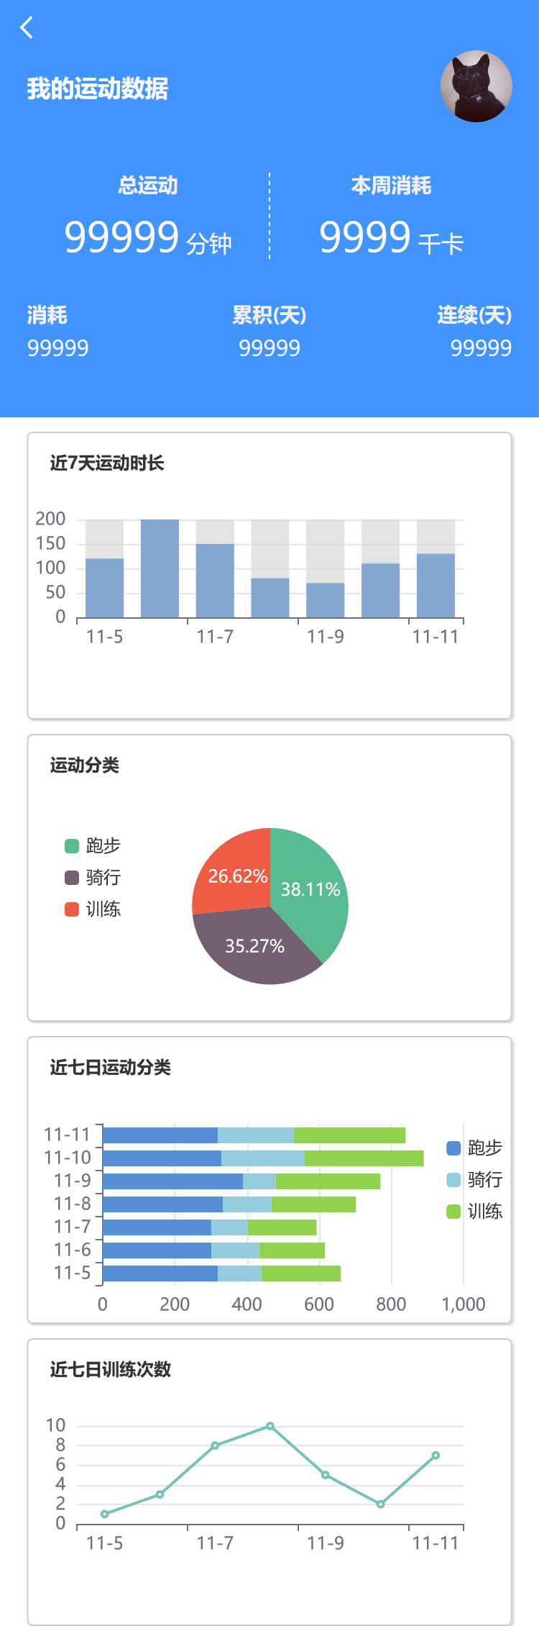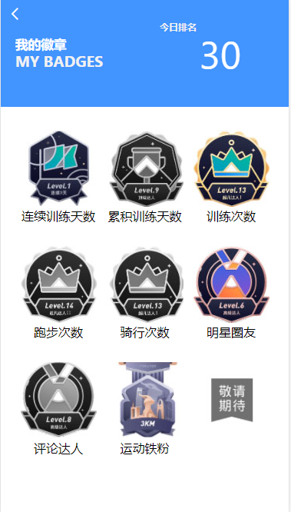

附：

设计稿地址：设计稿链接

修炼技术点
- echarts使用 & 查阅文档
- echarts自定义配置
- JavaScript对接口数据过滤、处理、拼装。
- Ajax请求接口联调、PostMan的使用

运动数据

头部布局实现
<div class="header">
<div class="header-container">
<div class="title dpflex">
<h3>我的运动数据</h3>
<img class="avatar" width="50" height="50" src="../images/头像.jpg" alt="">
</div>
<div class="data-total dpflex">
<div class="total-title dpflex fd-column">
<h6 class="title">总运动</h6>
<div>
<span class="num">99999</span> <span>分钟</span>
</div>
</div>
<div class="week-consume dpflex fd-column">
<h6 class="title">本周消耗</h6>
<div>
<span class="num">9999</span> <span>千卡</span>
</div>
</div>
</div>
<div class="other-data dpflex">
<div class="item-consume flex1 dpflex fd-column">
<h6 class="title">消耗</h6>
<span class="num">99999</span>
</div>
<div class="item-totalday flex1 dpflex fd-column">
<h6 class="title">累积(天)</h6>
<span class="num">99999</span>
</div>
<div class="item-continueday flex1 dpflex fd-column">
<h6 class="title">连续(天)</h6>
<span class="num">99999</span>
</div>
</div>
<i class="iconfont iconleftarrow"></i>
</div>
</div>

数据动态渲染
/* 获取运动数据 */
function getSportData() {
$http.get('/sport/data/1', function (res) {
let status = res.status
let data = res.data

if (status === 0) {
// 使用动态数据渲染头部
}
})
}
getSportData()

运动数据echarts

echarts的使用步骤
- 下载引入
<script src="../lib/echarts/echarts.js"></script>

- 准备一个具备宽和高的dom容器
<div id="box" style="height: 400px; background-color: #fff;"></div>

- 使用
// 1. 初始化echarts
const myChart = echarts.init(document.getElementById('box'))

// 2. 编写配置
const option = {
// 标题
title: {
text: 'ECharts 入门示例'
},
// 工具提示
tooltip: {},
// 图例
legend: {
data: ['销量']
},
// x轴配置
xAxis: {
data: ["衬衫", "羊毛衫", "雪纺衫", "裤子", "高跟鞋", "袜子"]
},
// y轴的配置
yAxis: {},
// 核心配置
series: [{
name: '销量',
type: 'bar',
data: [30, 20, 36, 10, 10, 20]
}]
}

// 3. 使用配置 创建echarts报表
myChart.setOption(option4)

近7天运动时长echart
/* 绘制柱状图 */
function drawBar() {
const chart = echarts.init(document.getElementById('sportTimeCharts'))
const option = {
title: {
text: "近7天运动时长",
textStyle: {
fontSize: 12,
color: '#333',
},
left: 10,
top: 10,
},
xAxis: {
type: 'category',
data: ['11-5', '11-6', '11-7', '11-8', '11-9', '11-10', '11-11']
},
yAxis: {
type: 'value'
},
series: [{
data: [120, 200, 150, 80, 70, 110, 130],
type: 'bar',
showBackground: true,
backgroundStyle: {
color: 'rgba(220, 220, 220, 0.8)'
},
itemStyle: {
color: '#83A7D1'
}
}]
}
chart.setOption(option)
}
drawBar() // 调用函数 绘制柱状图

运动分类echarts
/* 绘制饼图 */
function drawPie() {
const chart = echarts.init(document.getElementById('sportCategory'))
const option = {
title: {
text: '运动分类',
textStyle: {
fontSize: 12,
color: '#333'
},
left: 10,
top: 10,
},
tooltip: {
trigger: 'item',
formatter: '{b} : {c} ({d}%)'
},
legend: {
orient: 'vertical',
left: 20,
top: 'middle',
data: ['跑步', '骑行', '训练'],
icon: 'roundRect',
itemWidth: 10,
itemHeight: 10,
},
series: [
{
name: '运动分类',
type: 'pie',
radius: '55%',
center: ['50%', '60%'],
data: [
{ value: 335, name: '跑步', itemStyle: { color: '#58BB92' } },
{ value: 310, name: '骑行', itemStyle: { color: '#736171' } },
{ value: 234, name: '训练', itemStyle: { color: '#EE5C43' } }
],
label: {
color: '#fff',
show: true,
position: 'inside',
formatter: '{d}%',
}
}
]
}
chart.setOption(option)
}
drawPie() // 调用函数 绘制饼状体

近7日运动分类echarts
/* 绘制堆叠条形图 */
function drawStackLine() {
const chart = echarts.init(document.getElementById('weekSportCategory'))
const option = {
title: {
text: '近七日运动分类',
textStyle: {
fontSize: 12,
color: '#333'
},
left: 10,
top: 10,
},
tooltip: {
trigger: 'axis',
axisPointer: { // 坐标轴指示器，坐标轴触发有效
type: 'shadow' // 默认为直线，可选为：'line' | 'shadow'
}
},
legend: {
data: ['跑步', '骑行', '训练'],
left: '85%',
top: 'middle',
orient: 'vertical',
itemWidth: 10,
itemHeight: 10,
},
grid: {
left: '3%',
right: '10%',
bottom: '3%',
containLabel: true,
},
xAxis: {
type: 'value'
},
yAxis: {
type: 'category',
data: ['11-5', '11-6', '11-7', '11-8', '11-9', '11-10', '11-11']
},
series: [
{
name: '跑步',
type: 'bar',
stack: '总量',
data: [320, 302, 301, 334, 390, 330, 320],
itemStyle: {
color: '#558ED5'
}
},
{
name: '骑行',
type: 'bar',
stack: '总量',
data: [120, 132, 101, 134, 90, 230, 210],
itemStyle: {
color: '#93CDDD'
}
},
{
name: '训练',
type: 'bar',
stack: '总量',
data: [220, 182, 191, 234, 290, 330, 310],
itemStyle: {
color: '#92D050'
}
},

]
}
chart.setOption(option)
}

近7日训练次数echarts
/* 绘制折线图 */
function drawLine() {
const chart = echarts.init(document.querySelector('#trainNum'))
const option = {
title: {
text: '近七日训练次数',
textStyle: {
fontSize: 12,
color: '#333'
},
left: 10,
top: 10,
},
xAxis: {
type: 'category',
data: ['11-5', '11-6', '11-7', '11-8', '11-9', '11-10', '11-11']
},
yAxis: {
type: 'value'
},
series: [{
data: [1, 3, 8, 10, 5, 2, 7],
type: 'line',
itemStyle: {
color: '#79C2B3'
}
}]
}
chart.setOption(option)
}
drawLine()

获取ajax接口数据动态渲染
/* 获取运动数据 */
function getSportData() {
$http.get('/sport/data/1', function (res) {
let status = res.status
let data = res.data

if (status === 0) {
// 使用动态数据 渲染报表
}
})
}
getSportData()

我的徽章

布局实现
<i class="iconfont iconleftarrow"></i>
<div class="header dpflex">
<div class="header-left flex1">
<h5 class="zh-text">我的徽章</h5>
<span class="en-text">MY BADGES</span>
</div>
<div class="header-right flex1 dpflex">
<h6 class="title">今日排名</h6>
<span class="rank-num" id="rankNum"></span>
</div>
</div>
<ul class="content flex1 dpflex" id="badgeList">
<li class="badge-item">
<img src="../images/mybadge01.jpg" alt="">
<span>连续训练天数</span>
</li>
<li class="badge-item">
<img src="../images/mybadge02.jpg" alt="">
<span>累积训练天数</span>
</li>
<li class="badge-item">
<img src="../images/mybadge03.jpg" alt="">
<span>训练次数</span>
</li>
<li class="badge-item">
<img src="../images/mybadge04.jpg" alt="">
<span>跑步次数</span>
</li>
<li class="badge-item">
<img src="../images/mybadge05.jpg" alt="">
<span>骑行次数</span>
</li>
<li class="badge-item">
<img src="../images/mybadge06.jpg" alt="">
<span>明星圈友</span>
</li>
<li class="badge-item">
<img src="../images/mybadge07.jpg" alt="">
<span>评论达人</span>
</li>
<li class="badge-item">
<img src="../images/mybadge08.jpg" alt="">
<span>运动铁粉</span>
</li>
<li class="badge-item">
<img src="../images/mybadge09.jpg" alt="">
<span></span>
</li>
</ul>

Ajax联调动态渲染
- 渲染徽章列表
/* 获取dom */
const badgeList = document.querySelector('#badgeList')
const rankNum = document.querySelector('#rankNum')
/* 渲染徽章列表 */
function randerBadgeList(data) {
let badgesArr = [
` <li class="badge-item">
<img src="../images/mybadge01.jpg" alt="">
<span>连续训练天数</span>
</li>`,
` <li class="badge-item">
<img src="../images/mybadge02.jpg" alt="">
<span>累积训练天数</span>
</li>`,
`<li class="badge-item">
<img src="../images/mybadge03.jpg" alt="">
<span>训练次数</span>
</li>`,
` <li class="badge-item">
<img src="../images/mybadge04.jpg" alt="">
<span>跑步次数</span>
</li>`,
` <li class="badge-item">
<img src="../images/mybadge05.jpg" alt="">
<span>骑行次数</span>
</li>`,
` <li class="badge-item">
<img src="../images/mybadge06.jpg" alt="">
<span>明星圈友</span>
</li>`,
` <li class="badge-item">
<img src="../images/mybadge07.jpg" alt="">
<span>评论达人</span>
</li>`,
`<li class="badge-item">
<img src="../images/mybadge08.jpg" alt="">
<span>运动铁粉</span>
</li>`,
` <li class="badge-item">
<img src="../images/mybadge09.jpg" alt="">
<span></span>
</li>`,
]

let renderData = badgesArr.filter(function (item, index) {
if (data.includes(index + 1) || index === badgesArr.length - 1) {
return true
} else {
return false
}
})

// 渲染
badgeList.innerHTML = renderData.join('')
}
/* 获取徽章数据 */
function getBadges() {
$http.get('/users/sportsBadge/1', function (res) {
let status = res.status
let data = res.data

if (status === 0) {
// 渲染徽章列表
randerBadgeList(data)
}
})
}
// 调用函数 获取用户徽章信息
getBadges()

- 渲染头部排名
/* 获取头部排名 */
function getSportData() {
$http.get('/headPageInfo/?userId=1', function (res) {
let status = res.status
if (status === 0) {
let rank = res.data.rank
rankNum.textContent = rank;
}
})
}
getSportData()

今日研发任务CheckList
- 运动数据界面布局实现
- 运动界面echarts实现 （4个echarts）
- 运动数据界面 ajax接口联调
- 我的徽章界面布局实现
- 我的徽章界面接口联调

PS：使用Git进行代码版本控制，commit格式：git commit -m “feat: 完成注册页背景图适配”

今日小结
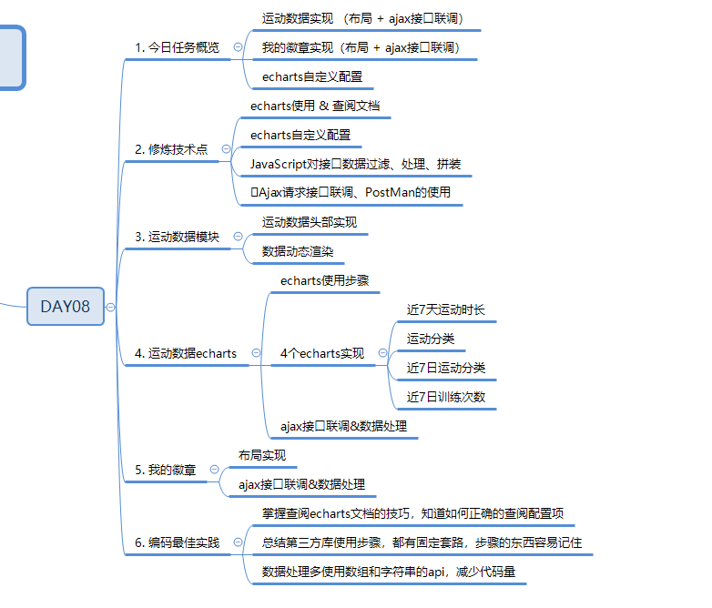

编码最佳实践
- 掌握查阅echarts文档的技巧，知道如何正确的查阅配置项
- 总结第三方库使用步骤，都有固定套路，步骤的东西容易记住
- 数据处理多使用数组和字符串的api，减少代码量

编码意识
- 遇到复杂的技术场景，先分析，再编码，必要时候甚至可以写一些伪代码；
- 复杂场景下，更需要注意命名以及写注释；

